**CSc 102 Project Proposal**

**19c2613 19p0818 19k5082**

TITLE FOR THE GAME: WAR-RIORS

BACKGROUND AND MOTIVATION :

War is an internationally recognized card game that is played with a full deck of 52 cards (the jokers are not included). There is no clear representation on how the game started but it is said to have spread around the world in the middle ages when people were confined to their homes during the plague. As they were indoors, ways of entertainment were playing cards thus the birth of ‘War’ (Natania, 2017)

The two-player game starts with a deck of cards split into half (26 each) and each player gets a set of cards all facing downwards. At the same time, each player turns up a card and the player with the higher card takes both cards and puts them at the bottom of his stack face down. The cards are ranked from highest to lowest where ace is the highest followed by king, queen, jack and ten through 2. The game continues in that manner until the player’s turnover cards are of the same value. At this point war has been declared. Each player then turns up one card (face up) and the other card facing downwards then the player with the highest card takes both piles and reshuffling takes place (Bicycle, 2019) If the cards had the same value, you repeat the previous step and the highest-values card collects the set. When a player runs out of cards they lose and the game is complete

This game can also be played with three or four players as long as the cards are equally divided between the group. War will be declared when at least two people have similar value cards then all the members battle for the pile. There are many variations to this game and a popular one is called ‘Casino War’ where the player deals with the house (the casino) and the winner gets money if they get a higher valued card. (McLeod, 1995)

PROBLEM STATEMENT:

The purpose of this version of the game ‘War’ is to get all the cards from the other player by betting the highest valued card one at a time. War has a low complexity and is suitable for young children to play. Components of the game are made more complex by adding features to game and adjusting it to suit environments such as the Casino version of war.

‘APPROACH’

In this project we aim to create a card game, written in the programming language Java. This game uses 52 cards and it is played by two individuals, but it is also conceivable for an individual to play against a computer adversary. The cards are distributed amongst the two players and each gets their own half-stack (26 cards), an array containing 52 slots will be required since the game can only be won if a participant obtains all the cards. Since the original game doesn’t need scorekeeping, we actually plan to include it to make the game more fascinating and to give an additional drive to the participants. Simple graphics are to be implemented to intensify the attractiveness of the game, and offer a much more hands-on experience. When war breaks (when the participants play tie) the user interface will display special effect indicating that the game has reached some sort of climax. An algorithm to include money for winnings will have to be implemented. So the winner also receives money.

TIMELINE

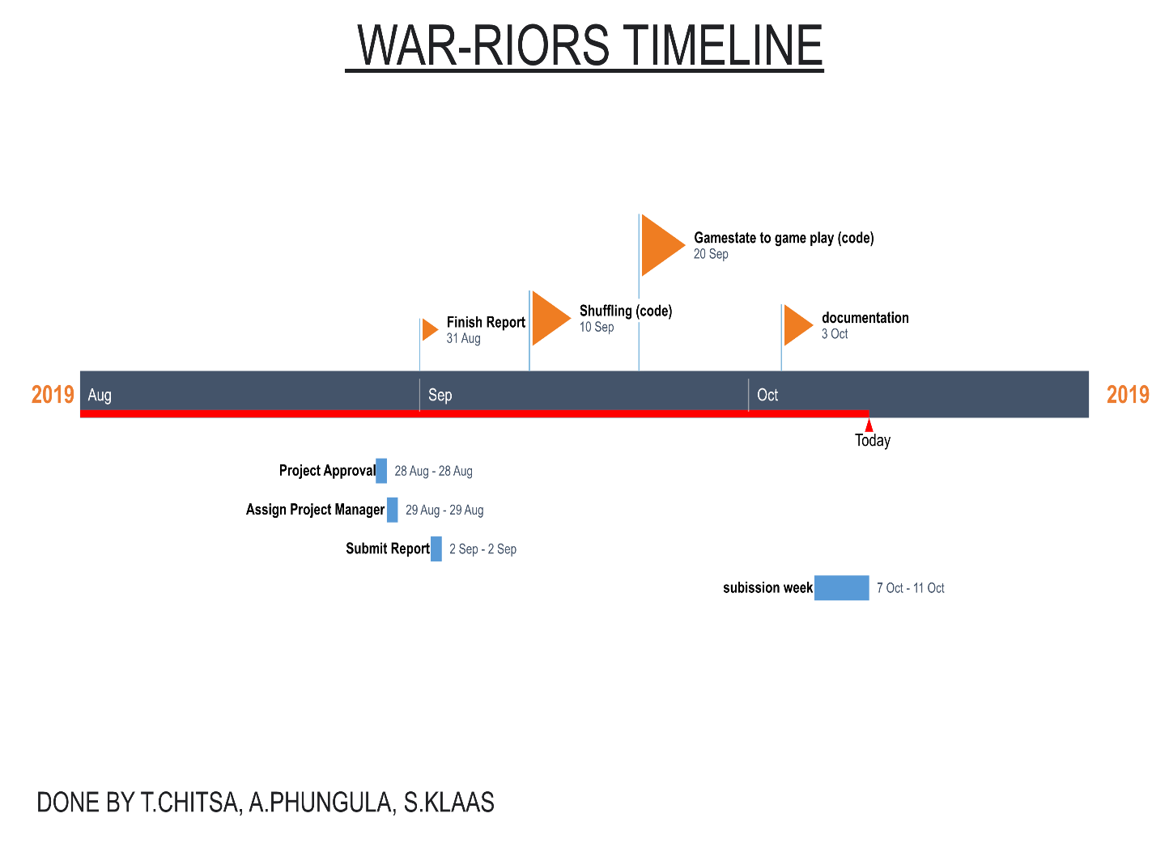

# References

Bicycle. (2019). *Bicycle Cards*. Retrieved from bicyclecards.com: https://bicyclecards.com/how-to-play/war/

McLeod, J. (1995). *Pagat*. Retrieved from www.pagat.com: https://www.pagat.com/war/war.html#tod_und_leben

Natania, C. (2017, February 14). *All Jackpots Casino*. Retrieved from www.alljackpotscasino.com: https://www.alljackpotscasino.com/blog/history-casino-war/